Program Features: Branch structure, variables, data input and output, mathematical operators, function calls.

Design a C++ application that calculates and displays all solutions to quadratic algebraic equations of the form

$$ax^{2}+bx+c=0$$

with real-numbered values of the constant coefficients a, b and c entered by the user. Your application should rely on the standard quadratic formulas:

$$x_{1}=\frac{-b+\sqrt{b^{2}-4ac}}{2a}$$

$$x_{2}=\frac{-b-\sqrt{b^{2}-4ac}}{2a}$$

Structure the program as shown in the following Flow Chart. It is recommended that you perfect the structure of the program before including the calculations.

Start
a == 0
Y
N
b == 0
b²–4ac
> 0
b²–4ac
== 0
Y
N
“No solution.”
“One real solution.”
“Two real unequal solutions.”
“Two real equal solutions.”
“Two complex conjugate solutions.”
Y
N
Y
N
Prompt user for a, b and c.

Following a common practice among electrical engineers, use the symbol j in your display to represent the square root of –1.

Document the program with the following sections:

A. A brief written description of the purpose of the program including the inputs, the outputs and a description of the structure of the programming.

The Quadratic Equation Solver calculates solutions for equations of the form
ax^(2) +bx +c = 0. The user enters values for a, b, and c, while the program determines the types of solutions based on the discriminant (b^(2) -4ac). It then displays two real solutions, one repeated real solution, or two complex solutions. If a = 0, then the program checks if the equation is linear or has no solution. The program uses simple conditions to classify and display the correct result.

B. A flowchart including all of the equations for the various solutions.
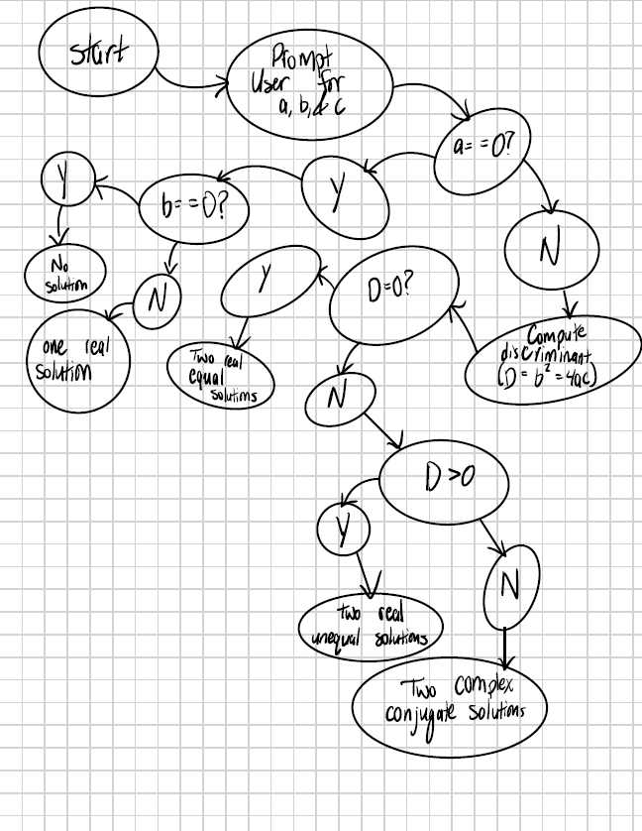

C. Source Code:
#include <iostream>
#include <cmath>

using namespace std;
int main()
{
double a, b, c;

// User input
cout << "Quadratic Equation Solver" << endl;
cout << "Enter coefficient a: ";
cin >> a;
cout << "Enter coefficient b: ";
cin >> b;
cout << "Enter coefficient c: ";
cin >> c;

// Check if it's a valid quadratic equation
if (a == 0) {
if (b == 0) {
cout << "No solution." << endl;
}
else {
double x = -c / b;
cout << "One real solution: x = " << x << endl;
}
return 0;
}

// Compute the discriminant
double discriminant = b * b - 4 * a * c;

// Determine the nature of the roots
if (discriminant > 0) {
double x1 = (-b + sqrt(discriminant)) / (2 * a);
double x2 = (-b - sqrt(discriminant)) / (2 * a);
cout << "Two real unequal solutions: x1 = " << x1 << ", x2 = " << x2 << endl;
}
else if (discriminant == 0) {
double x = -b / (2 * a);
cout << "Two real equal solutions: x = " << x << endl;
}
else {
double realPart = -b / (2 * a);
double imaginaryPart = sqrt(-discriminant) / (2 * a);
cout << "Two complex conjugate solutions: x1 = " << realPart << " + " << imaginaryPart << "j, ";
cout << "x2 = " << realPart << " - " << imaginaryPart << "j" << endl;
}

system("pause");
return 0;
}

D. Screen capture images showing the operation of the program for each of the possible solutions.

